Wire Battery Power

The operating voltage of ESP32 ranges from 2.3 V to 3.6 V.

When using a single-power supply, the recommended voltage of the power supply is 3.3 V, and its recommended output current is 500 mA or more.

|  |  |  |  |
| --- | --- | --- | --- |
| Battery Option | Capacity (mAh) | Voltage | Cost/Unit |
| 2 AA (Alkaline) | 4000* | (2)1.5V = 3V* | 72 @ $0.3 plus case($0.41) = $1.10 per unit |

*The capacity and voltage varies with time and power consumption.

The following graphs[1] describe the output voltage of a Duracell coppertop alkaline AA battery with respect to power consumption.

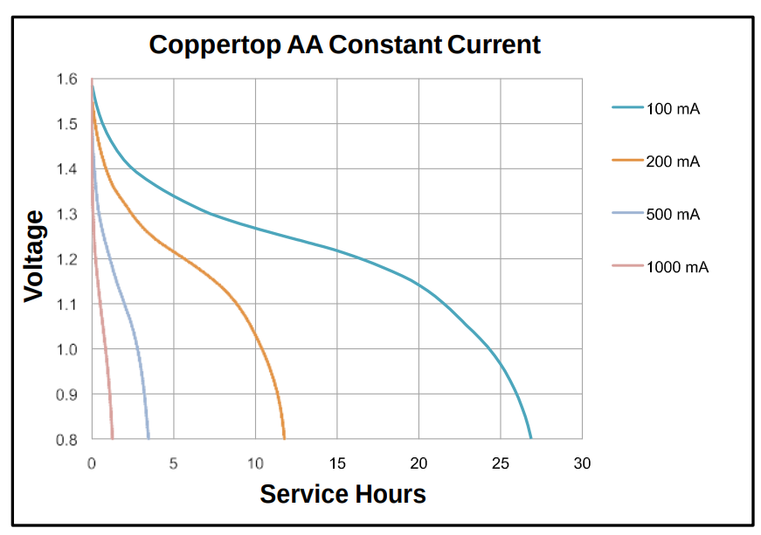

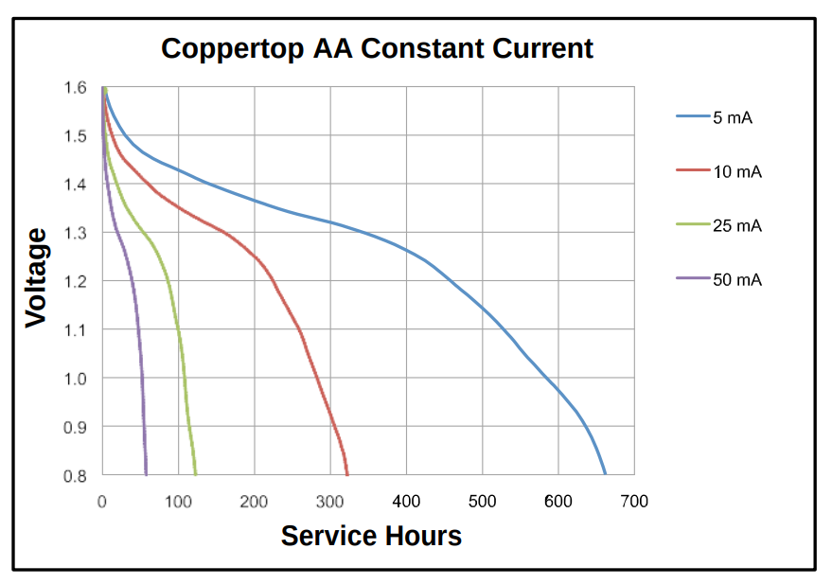

With a minimum operating voltage of 2.3V, each battery must output 2.3/2 = 1.15V. The following table uses the above graphs to approximate the life of the station at various levels of power consumption.

## 2 AA Power Draw

|  |  |  |
| --- | --- | --- |
| Hours of life | Days of Life | Consumption (mA) |
| 980 | 40.84 | 5 |
| 480 | 20 | 10 |
| 180 | 7.5 | 25 |
| 90 | 3.75 | 50 |
| 40 | 1.667 | 100 |
| 15 | 0.625 | 200 |
| 4 | 0.167 | 500 |

This table brings greater concern to the ability of satisfying the requirement of a year-long battery life. To reasonably approach this goal it would require battery capacity of at least nine times that of two AA batteries (generously using an average consumption of 5mA).

To meet this requirement we may need more than 2 AA batteries, in combination with an LDO.

The MCP1703 is one such regulator with 250 mA maximum output current, supporting input voltage of up to 16V. 16V would theoretically support 10 AA batteries, which would theoretically last for the one year time period, though size becomes an additional concern as more batteries are introduced. The exact specifications can be determined during the second sprint when the amount of power consumption is approximated.

# Wiring

For our AA batteries, power is supplied to the 3v3 pin on either side, and grounded on a GND pin. The VBAT is only to be used with Lipo batteries.

Here is the chip running the code to blink the LED off of 2 AA alkaline batteries.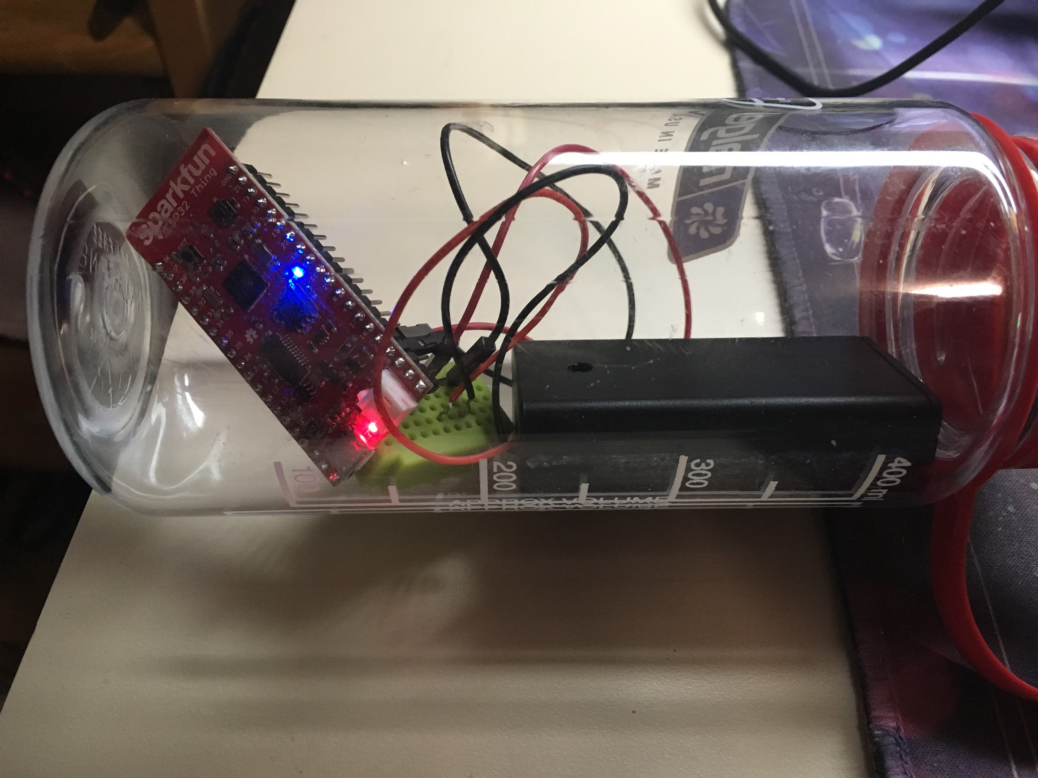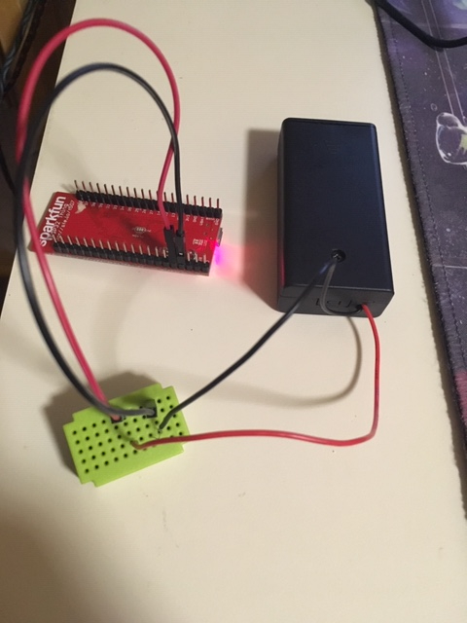

# Other Considerations

3.3V Lipo batteries were considered as well, as they are the only other reasonably obtainable battery with more capacity per size (~130% of the Alkaline). They were discarded due to their price and this project’s inability to make use of their rechargeability. Perhaps a solar or wave power element could be added in the future to elevate the potential of these batteries. Alkaline also doesn’t raise any concerns or need for caution, while additional risks are incurred with the use of Lipo batteries.

# Data Sources

[1]

https://www.duracell.com/en-ca/techlibrary/product-technical-data-sheets